TERMWORK 2
NAME: name_here
USN: 2GI20CSXXX

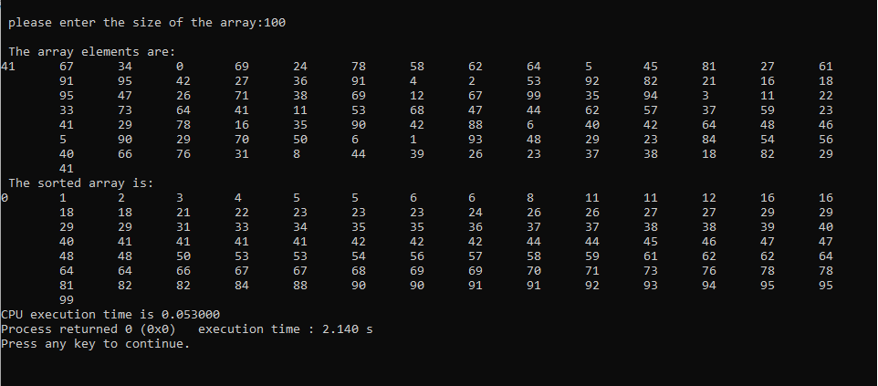
n | t
100 | 0.053
200 | 0.656
300 | 0.985
400 | 1.066
500 | 1.4

